UNIT 1
Overview of Data Structure, Elementary Data Structure Organization,Classification of Data Structures,Abstract Data Types.

Overview of Data Structure :-
https://www.youtube.com/watch?v=3cU__spdMIw&list=PLxCzCOWd7aiEwaANNt3OqJPVIxwp2ebiT&index=2

What is Data Structure?
A data structure is a particular way of organising data in a computer so that it can be used effectively. The idea is to reduce the space and time complexities of different tasks.
OR
A data structure is a storage that is used to store and organize data. It is a way of arranging data on a computer so that it can be accessed and updated efficiently.

Need Of Data Structure:
The structure of the data and the synthesis of the algorithm are relative to each other. Data presentation must be easy to understand so the developer, as well as the user, can make an efficient implementation of the operation. Data structures provide an easy way of organising, retrieving, managing, and storing data.
Here is a list of the needs for data.
- Data structure modification is easy.
- It requires less time.
- Save storage memory space.
- Data representation is easy.
- Easy access to the large database
Applications of Data Structures:
Data structures are used in various fields such as:
- Operating system
- Graphics
- Computer Design
- Blockchain
- Genetics
- Image Processing
- Simulation,
- etc.

Classification of Data Structures :-
https://www.youtube.com/watch?v=UKEYTI1V0Vw
https://www.youtube.com/watch?v=T9DSBhBR_I4

By using data structure, one can organize and process a very large amount of data in a relatively short period. Let's look at different data structures that are used in different situations.

Classification/Types of Data Structures:
- Primitive data structure
Int, float,char,double,pointer etc
- Non Primitive data structure
- Linear Data Structure
- Non-Linear Data Structure.
Linear Data Structure:
- Elements are arranged in one dimension ,also known as linear dimension.
- Linear data structures store elements sequentially. Each element is connected to the next one Next element ka address = Previous address + 4, and they can be traversed in a single pass.
for(i = 0; i < n; i++)
print(arr[i]);
- Example: lists, stack, queue, etc.
Non-Linear Data Structure
- Elements are arranged in one-many, many-one and many-many dimensions.
This means one element can be connected to one or more elements at the same time.
One-to-Many: One parent node is connected to many child nodes (as in a Tree).
A
/ \
B C
Many-to-One: Many nodes are connected to a single node.
B ─┐
C ─┼──> A
D ─┘
Many-to-Many: Many nodes are connected with many other nodes (as in a Graph).
A ─── B
| |
C ─── D

- Non-linear data structures organize data in a way that doesn't follow a sequential order. They are useful for complex relationships between data.
- Example: tree, graph, table
- , etc.

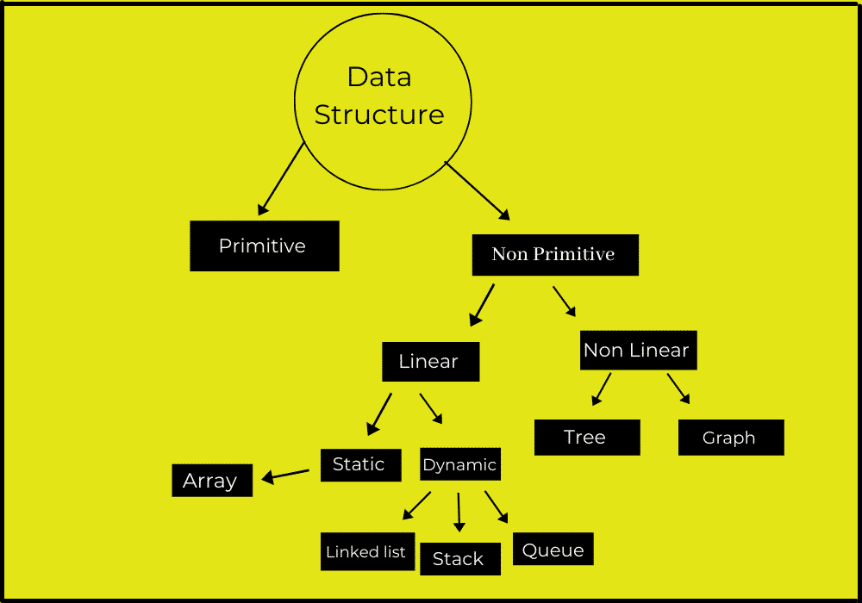
Static and dynamic data structures are two categories based on how the size and memory allocation of the structure are handled
Static Data Structure
A static data structure has a fixed size, meaning the amount of memory required for the structure is determined at compile time and cannot be changed during runtime.
Characteristics:
- Fixed Memory Allocation: The size of the structure is allocated at the start and remains constant.
- Efficient Memory Access: Since memory is allocated in a contiguous block, accessing elements is faster.
- Predictability: Static data structures are predictable in terms of memory usage, making them easier to manage.
- Inflexibility: Since the size cannot be altered, static structures are less flexible for scenarios with varying data sizes.
Examples:
- Array:
  - Size is fixed when declared.
  - Example: int arr[10];
- Static Stack or Queue:
  - Implemented using arrays with a predefined size.
  - Example: int stack[100];
Advantages:
- Simpler to implement.
- No risk of external fragmentation since memory is allocated in one contiguous block.
- Faster access to elements due to contiguous memory allocation.
Disadvantages:
- Wastage of memory if the allocated size is larger than needed.
- Limited flexibility to handle varying data size

Dynamic Data Structure
A dynamic data structure can grow or shrink in size during runtime, meaning memory allocation and deallocation are handled dynamically as needed.
Characteristics:
- Flexible Memory Allocation: Memory is allocated or freed as data is added or removed.
- Dynamic Growth: The size of the structure can be adjusted based on runtime requirements.
- More Complex Implementation: Requires additional overhead for managing pointers and dynamic memory.
Examples:
- Linked List:
  - Nodes are created dynamically, and the size can grow or shrink.
- Dynamic Stack or Queue:
  - Implemented using linked lists or resizable arrays (e.g., std::vector in C++, ArrayList in Java).
- Dynamic Arrays (Resizable Arrays):
  - Example: Python’s list, or Java’s ArrayList.
- Graphs and Trees:
  - Typically implemented dynamically to handle variable sizes and relationships.
Advantages:
- Efficient use of memory, as only the required space is allocated.
- Better suited for situations where the size of the data set is unknown or varies over time.
Disadvantages:
- Slower access time due to non-contiguous memory allocation.
- Risk of memory fragmentation or memory leaks if dynamic memory is not managed properly.
- More complex implementation requiring pointers and dynamic memory management.

Most Popular Data Structures:
1. Array:
An array is a collection of data items stored at contiguous memory locations. The idea is to store multiple items of the same type together. This makes it easier to calculate the position of each element by simply adding an offset to a base value, i.e., the memory location of the first element of the array (generally denoted by the name of the array).

address = base_address + (index × size_of_data_type)
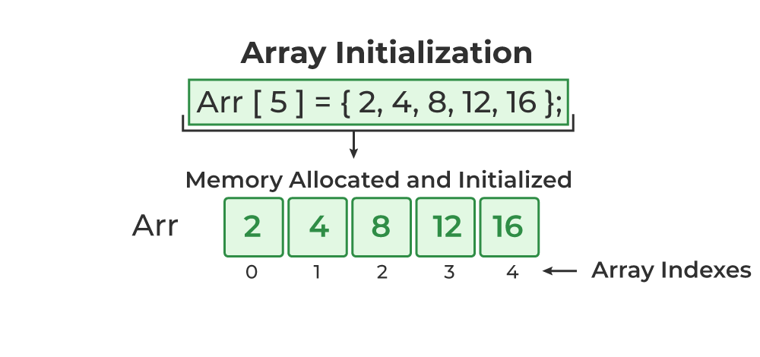
address = base_address + (index × size_of_data_type)

Assume:
base_address = 1000
size_of_data_type (int) = 4 bytes

- Address of arr[0]
= 1000 + (0 × 4)
= 1000 + 0
= 1000

- Address of arr[1]
= 1000 + (1 × 4)
= 1000 + 4
= 1004

2. Linked Lists:
Like arrays, Linked List is a linear data structure. Unlike arrays, linked list elements are not stored at a contiguous location; the elements are linked using pointers.
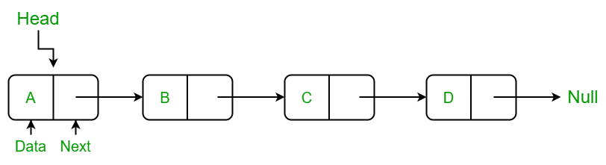

3. Stack:
Stack is a linear data structure which follows a particular order in which the operations are performed. The order may be LIFO(Last In First Out) or FILO(First In Last Out). In stack, all insertion and deletion are permitted at only one end of the list.
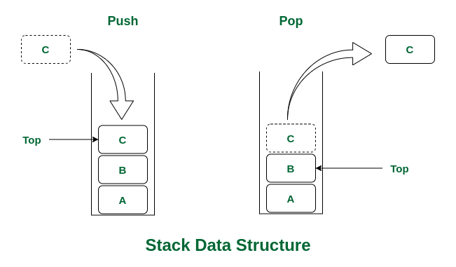
Stack Operations:
- push(): When this operation is performed, an element is inserted into the stack.
- pop(): When this operation is performed, an element is removed from the top of the stack and is returned.
- top(): This operation will return the last inserted element that is at the top without removing it.
- size(): This operation will return the size of the stack i.e. the total number of elements present in the stack.
- isEmpty(): This operation indicates whether the stack is empty or not.
4. Queue:
Like Stack, Queue is a linear structure which follows a particular order in which the operations are performed. The order is First In First Out (FIFO). In the queue, items are inserted at one end and deleted from the other end. A good example of the queue is any queue of consumers for a resource where the consumer that came first is served first. The difference between stacks and queues is in removing. In a stack we remove the item the most recently added; in a queue, we remove the item the least recently added.
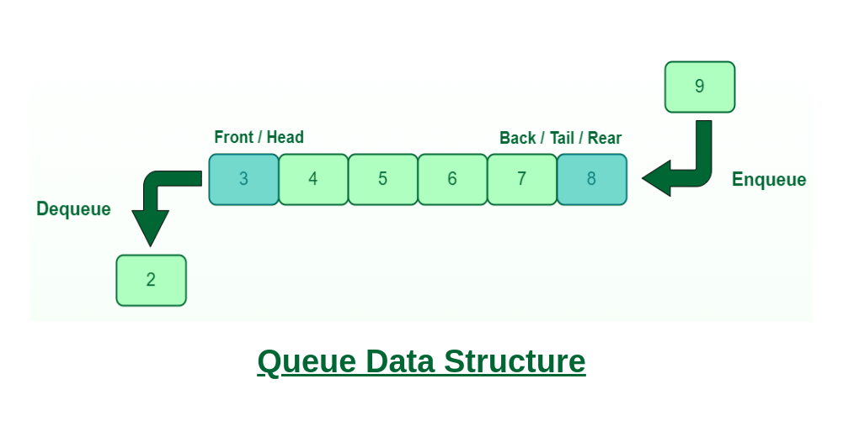
Queue Operations:
- Enqueue(): Adds (or stores) an element to the end of the queue..
- Dequeue(): Removal of elements from the queue.
- Peek() or front(): Acquires the data element available at the front node of the queue without deleting it.
- rear(): This operation returns the element at the rear end without removing it.
- isFull(): Validates if the queue is full.
- isNull(): Checks if the queue is empty.
5. Binary Tree:
Unlike Arrays, Linked Lists, Stack and queues, which are linear data structures, trees are hierarchical data structures. A binary tree is a tree data structure in which each node has at most two children, which are referred to as the left child and the right child. It is implemented mainly using Links.
A Binary Tree is represented by a pointer to the topmost node in the tree. If the tree is empty, then the value of root is NULL. A Binary Tree node contains the following parts.
1. Data
2. Pointer to left child
3. Pointer to the right child
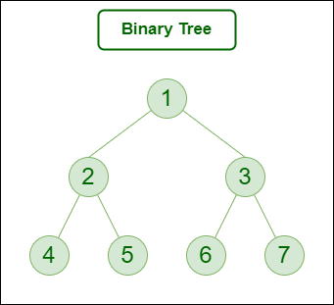
6. Binary Search Tree:
A Binary Search Tree is a Binary Tree following the additional properties:
- The left part of the root node contains keys less than the root node key.
- The right part of the root node contains keys greater than the root node key.
- There is no duplicate key present in the binary tree.
A Binary tree having the following properties is known as Binary search tree (BST).

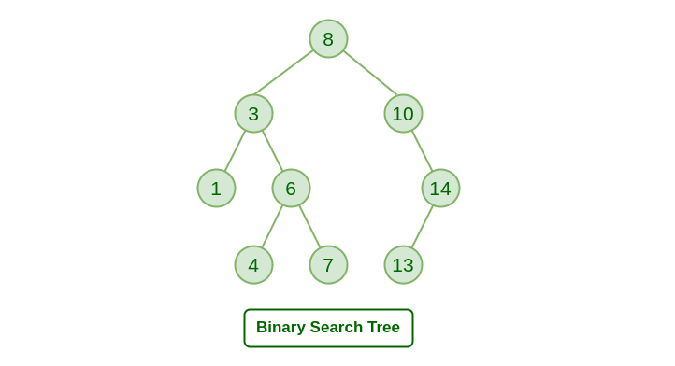
7. Heap:
A Heap is a special Tree-based data structure in which the tree is a complete binary tree. Generally, Heaps can be of two types:
- Max-Heap: In a Max-Heap the key present at the root node must be greatest among the keys present at all of its children. The same property must be recursively true for all sub-trees in that Binary Tree.
- Min-Heap: In a Min-Heap the key present at the root node must be minimum among the keys present at all of its children. The same property must be recursively true for all sub-trees in that Binary Tree.
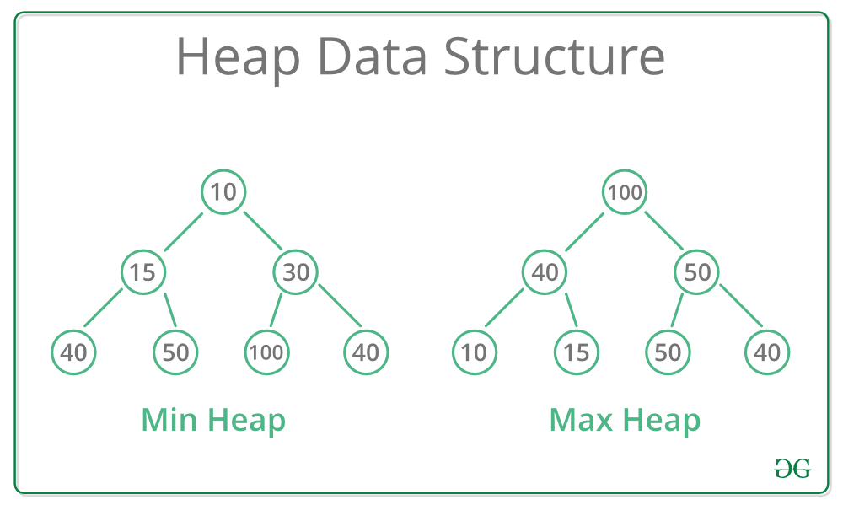

8. Graph:
Graph is a data structure that consists of a collection of nodes (vertices) connected by edges. Graphs are used to represent relationships between objects and are widely used in computer science, mathematics, and other fields. Graphs can be used to model a wide variety of real-world systems, such as social networks, transportation networks, and computer networks.
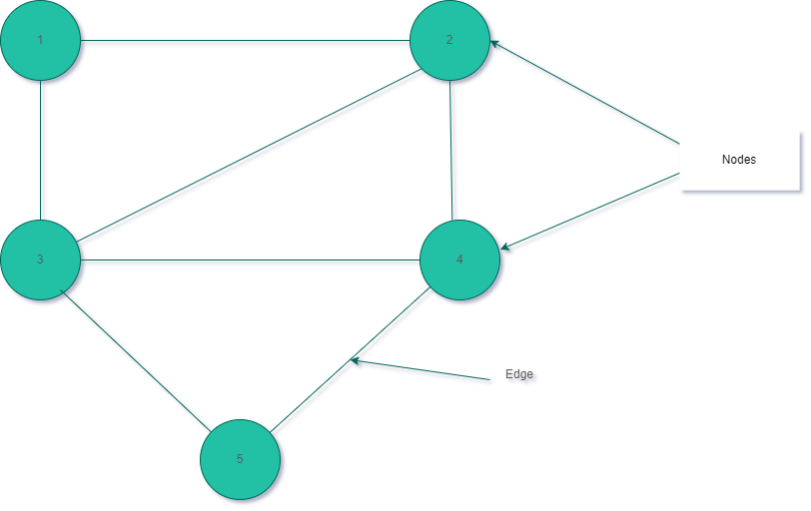

Operations on Data Structures and Abstract Data Type

Data types such as int, float, double, and long are built-in types that allow us to perform basic operations like addition, subtraction, division, and multiplication. However, there are scenarios where we need custom operations for different data types. These operations are defined based on specific requirements and are tailored as needed. To address such needs, we can create data structures along with their operations, which are known as Abstract Data Types (ADTs).
An Abstract Data Type (ADT) is a conceptual model that defines a set of operations and behaviours for a data type, without specifying how these operations are implemented or how data is organized in memory. The definition of ADT only mentions what operations are to be performed but not how these operations will be implemented. It does not specify how data will be organized in memory and what algorithms will be used for implementing the operations. It is called “abstract” because it provides an implementation-independent view.
The process of providing only the essentials and hiding the details is known as abstraction.
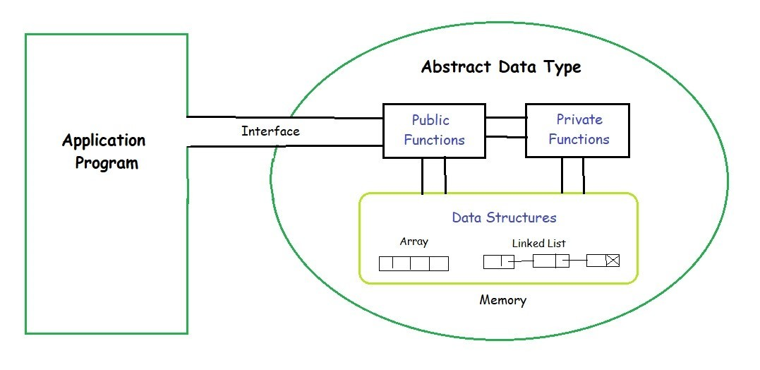

1. List ADT
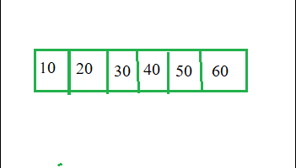
Vies of list
The List ADT need to store the required data in the sequence and should have the following operations:
- get(): Return an element from the list at any given position.
- insert(): Insert an element at any position in the list.
- remove(): Remove the first occurrence of any element from a non-empty list.
- removeAt(): Remove the element at a specified location from a non-empty list.
- replace(): Replace an element at any position with another element.
- size(): Return the number of elements in the list.
- isEmpty(): Return true if the list is empty; otherwise, return false.
- isFull(): Return true if the list is full; otherwise, return false.

2. Stack ADT
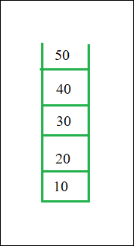
View of stack
In Stack ADT, the order of insertion and deletion should be according to the FILO or LIFO Principle. Elements are inserted and removed from the same end, called the top of the stack. It should also support the following operations:
- push(): Insert an element at one end of the stack called the top.
- pop(): Remove and return the element at the top of the stack, if it is not empty.
- peek(): Return the element at the top of the stack without removing it, if the stack is not empty.
- size(): Return the number of elements in the stack.
- isEmpty(): Return true if the stack is empty; otherwise, return false.
- isFull(): Return true if the stack is full; otherwise, return false.

3. Queue ADT
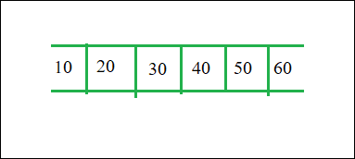
View of Queue
The Queue ADT follows a design similar to the Stack ADT, but the order of insertion and deletion changes to FIFO. Elements are inserted at one end (called the rear) and removed from the other end (called the front). It should support the following operations:
- enqueue(): Insert an element at the end of the queue.
- dequeue(): Remove and return the first element of the queue, if the queue is not empty.
- peek(): Return the element of the queue without removing it, if the queue is not empty.
- size(): Return the number of elements in the queue.
- isEmpty(): Return true if the queue is empty; otherwise, return false.

Advantages:
- Encapsulation: ADTs provide a way to encapsulate data and operations into a single unit, making it easier to manage and modify the data structure.
- Abstraction: ADTs allow users to work with data structures without having to know the implementation details, which can simplify programming and reduce errors.
- Data Structure Independence: ADTs can be implemented using different data structures, which can make it easier to adapt to changing needs and requirements.
- Information Hiding: ADTs can protect the integrity of data by controlling access and preventing unauthorized modifications.
- Modularity: ADTs can be combined with other ADTs to form more complex data structures, which can increase flexibility and modularity in programming.

Disadvantages:
- Overhead: Implementing ADTs can add overhead in terms of memory and processing, which can affect performance.
- Complexity: ADTs can be complex to implement, especially for large and complex data structures.
- Learning Curve: Using ADTs requires knowledge of their implementation and usage, which can take time and effort to learn.
- Limited Flexibility: Some ADTs may be limited in their functionality or may not be suitable for all types of data structures.
- Cost: Implementing ADTs may require additional resources and investment, which can increase the cost of development.

